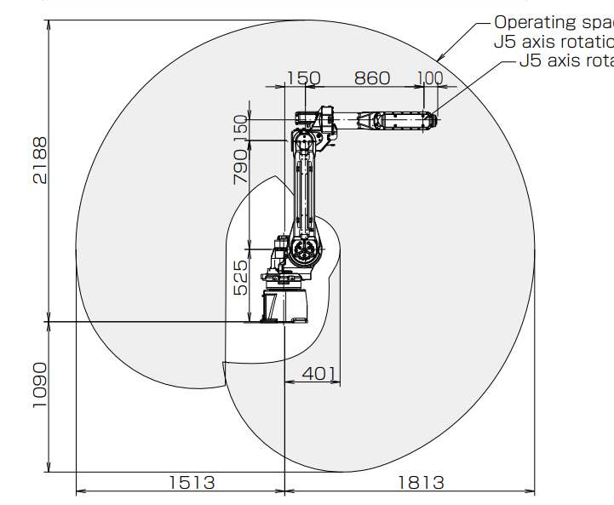

**X Y Z**

**Parametri D-H**

|  |  |  |  |  |
| --- | --- | --- | --- | --- |
|  | d | teta | a | alfa |
| 1 | 0.525 | q1 | 0.150 | - pigreco mezzi |
| 2 | 0 | q2 – pigreco mezzi | 0.790 | 0 |
| 3 | 0 | q3 | 0.150 | - pigreco mezzi |
| 4 | 0.860 | q4 | 0 | pigreco mezzi |
| 5 | 0 | q5 | 0 | -pigreco mezzi |
| 6 | 0.100 | q6 | 0 | 0 |